Changes document for MS Decom activities

Project: z_i740_icy

System : xFE

CD: 151938.

Transport request: DFEK962733

—---------------------------------------------------------------------------------------------------------------------------------

1. Add new button for Export to my Drive option to export data into google sheet.

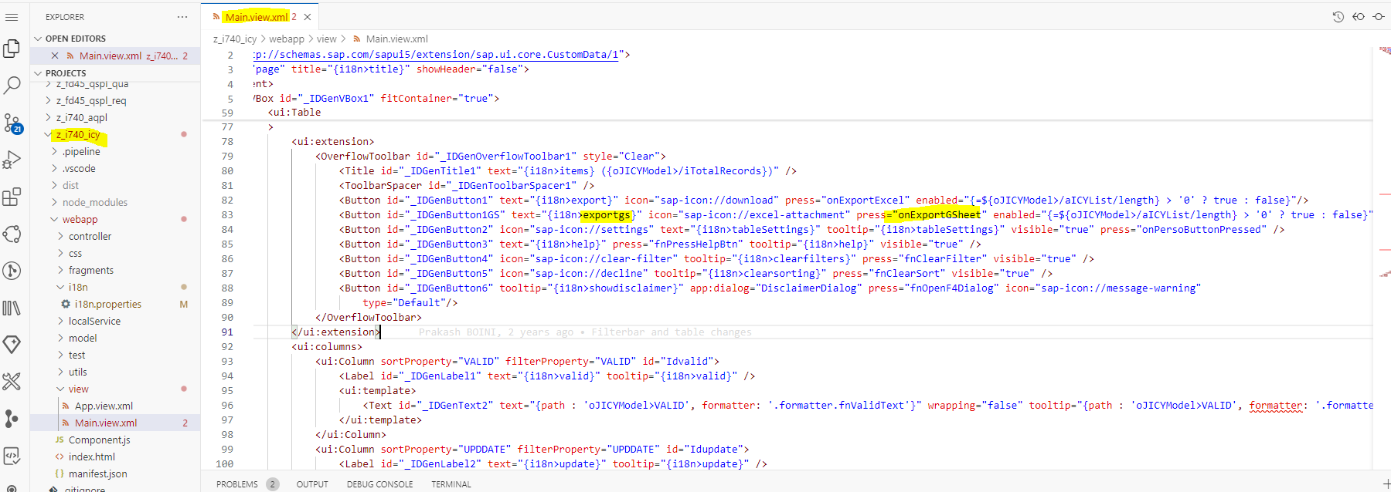

1. Below logic to extract the data in the form of google sheet.

